Resident Portal Instructions for Tenants

Berg Management, in cooperation with PropertyBoss® Solutions, our property management software, now offers on-line access for tenants to view their lease account charges and make payments, update contact information, view any documents that have been uploaded, and view and create Work Orders.

This will be the primary access to information, payments, and any other transactions concerning your lease, going forward. Having direct access to your lease account will provide you with current information and status, as well as giving you more options for managing your lease account. We hope this new system will be beneficial and thank you for being our tenant.

In order to create/register an account on line, you MUST use the e-mail that we have on file for you. If you try to register with a different e-mail address, you will have to wait for us to verify the e-mail and update it in our system.

To create/register an account on line, go to this link in Google Chrome on any computer with Internet access (other browsers or cell phones do not work as good at this time):

www.bergtenant.com

The following screen will appear:
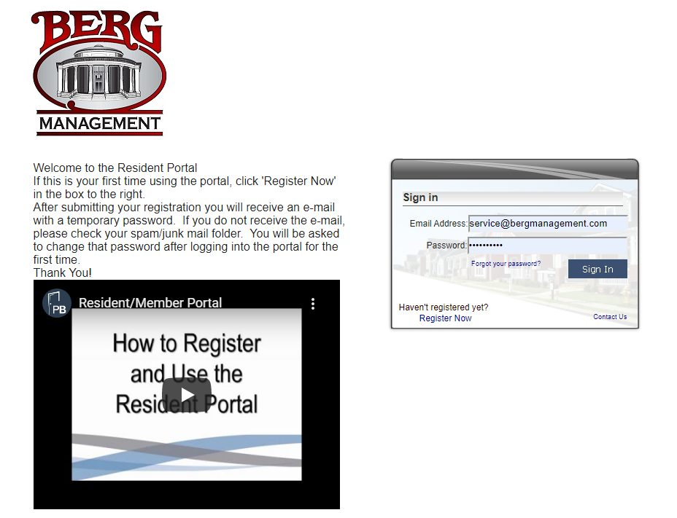

If this is the first time you are entering the portal, follow the instructions to “Register Now” or view the video on how to Register and Use the Resident Portal.

You will need to provide your e-mail, name, phone number, and property address:
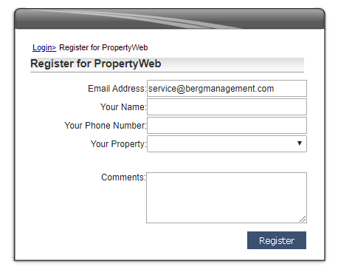

If your e-mail matches what we have in the system, you will receive an e-mail confirmation with a link to reset your password. It will look like this:

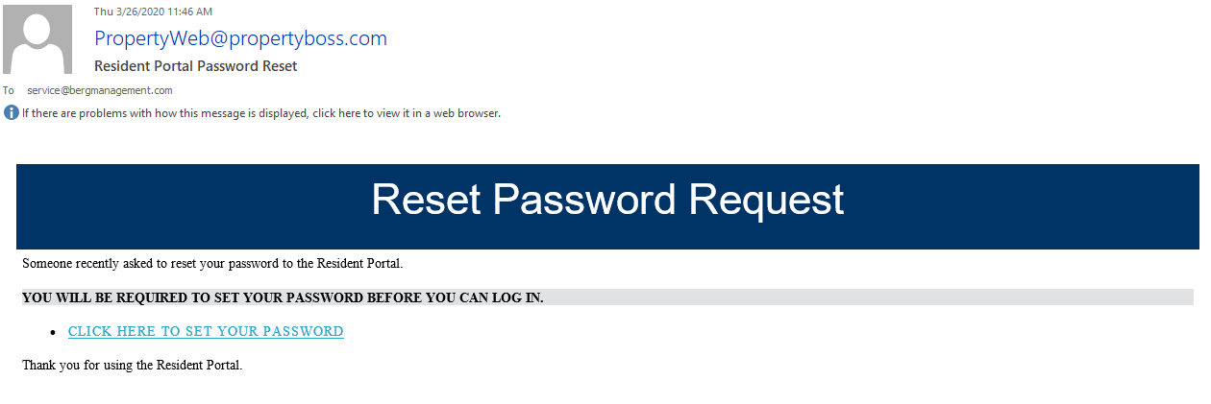

Click the link to set your password and access your account information.

Once logged in, you will see the following screen:

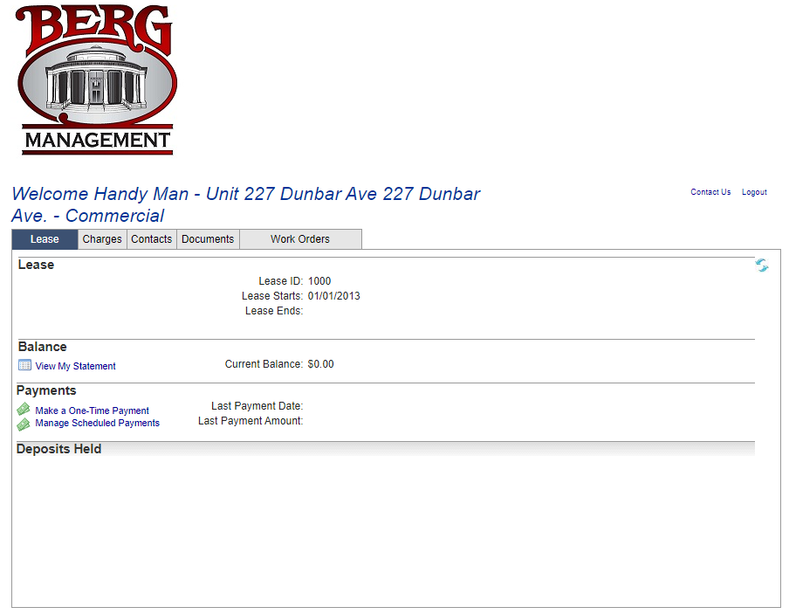
On the Lease tab you may view your statement, make a one-time payment, or schedule recurring payments by clicking the links.

You can view other charges by clicking on the Charges tab, update your contact information (phone number, emergency contact, billing address, etc.) by clicking the Contacts tab, view any Documents that have been uploaded to your account (lease paperwork, addendums, etc.), or view/create/change Work Orders for your unit.

If you choose to make a one-time payment, you will see the following screen:

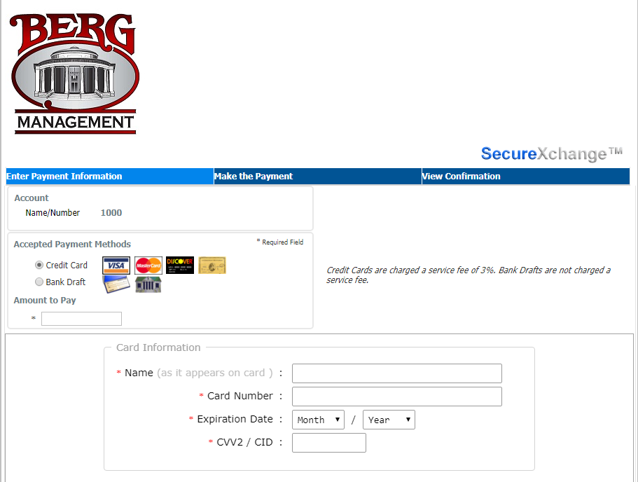

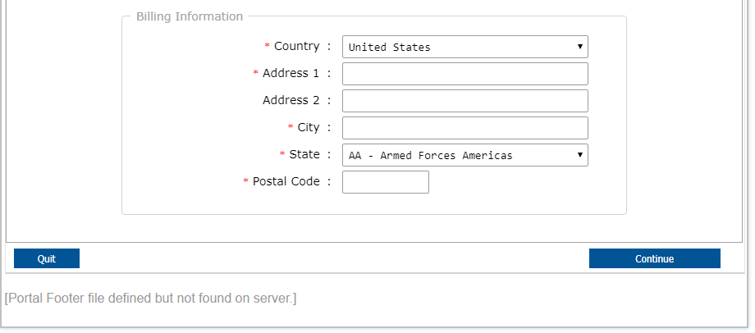

Choose Credit Card or Bank Draft and fill in the appropriate information.

**Please note that Credit Card payments will have an additional 3% processing fee added to the amount you pay and entering incorrect Bank information/NSF will result in a $10.00 fee.

ALL fields are required! A dollar sign is NOT required in the “Amount to Pay” field.

Click Continue to review your payment information.

Then authorize the payment by clicking “Make the Payment.”

You will receive a confirmation number – This is ONLY confirmation that your payment has been submitted. It does NOT mean that the funds have been transferred. It could take up to three to five business days for payments to appear on your account, depending on the time of day that you send it, when Berg processes it, and when your financial institution processes it.

If you choose to make a SCHEDULED or Recurring payment, you will see the following screen: Please NOTE that YOU are responsible for starting and stopping these payments.

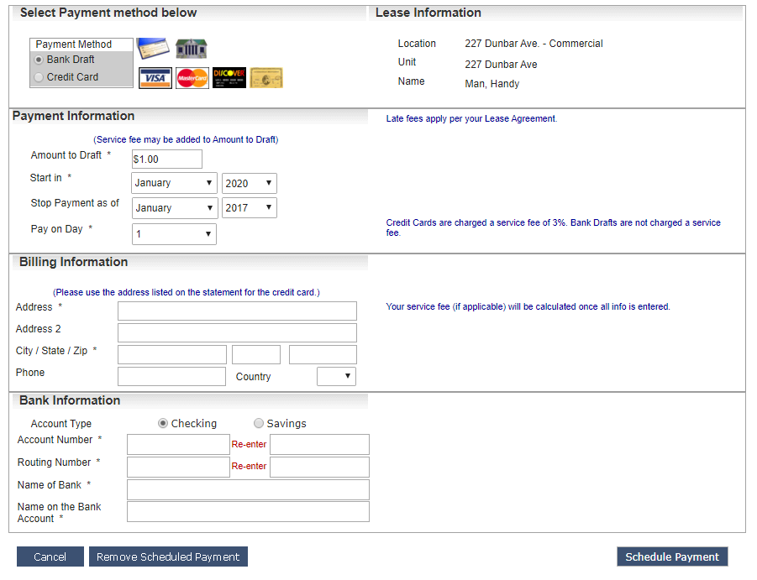

Choose Credit Card or Bank Draft and fill in the appropriate information.

**Please note that Credit Card payments will have an additional 3% processing fee added to the amount you pay and entering incorrect Bank information/NSF will result in a $10.00 fee.

ALL fields with an asterisk are required!

Review your information, then authorize the payment by clicking “Schedule Payment.”

You will receive a confirmation number – This is ONLY confirmation that your payment has been submitted. It does NOT mean that the funds have been transferred. It could take up to three to five business days for payments to appear on your account, depending on the time of day that you send it, when Berg processes it, and when your financial institution processes it.

At this time, it is not possible to change a scheduled payment. You will have to Remove the Scheduled Payment and then start over.

